Notifications in the caGrid Portal

Use Case: caGrid Portal assigns several statuses to the grid services. Some of these status assignments denot a service to be inactive or otherwise unsuitable for users. These services are marked as “Dormant” or “Banned” in the caGrid Portal and filtered out in the User Interface (UI).
Service are assumed to be inactive if any of the following is true
- Service is not responding or is offline
- Service is not currently advertising in the caGrid Index.
Services that remain inactive for prolonged periods of time are marked as Dormant. Only the Portal administrator can mark the service as Banned. The below state diagram illustrates the above behavior

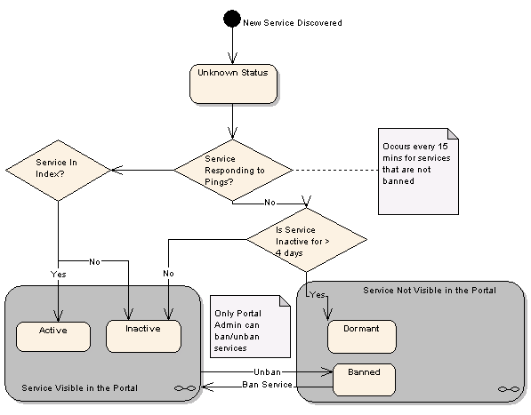
Figure 1 Portal Status assignment
The notification use case in general can be illustrated with the following State diagram. The Portal should have the ability to send out notifications to relevant parties when a service is put in any status that will hide the service in the UI. But it can also be interpreted as – the Portal should have the ability to send out notifications on ANY status change.

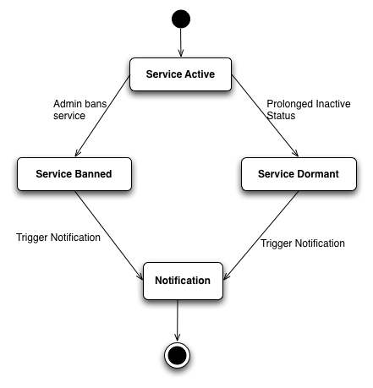
Figure 2 Notifications

There are a few alternatives as far as implementation is concerned. These are outlined below

Implementation 1: Automatic Notifications

Summary: Notifications should be triggered automatically and sent out to the services Point of Contact
Description: Since grid service as part of their standard metadata publish the Service and Cancer Center Point of Contact, the notification framework could leverage this information and automatically trigger notifications that are sent to these Point of Contact(s). This approach is illustrated below
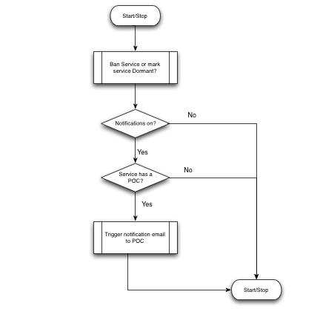
Figure 3 Notifications to POC
Advantages: This will have minimal impact on the Portal system administrators and users. There is no action needed from the users of the Portal and notifications will work seamlessly.
Drawbacks: This has the potential to generate spam email (any automated email that is not subscribed to can be considered spam). Also, there might be stakeholders that are not the Point of Contact for a service but wish to receive these notifications

Implementation 2: Allow users to register for notifications

Summary: Let users register for notifications they wish to receive for any service in the Portal
Description: Through a special notifications Portlet or in the service details page we should allow users to manage the notifications they receive for a given grid service.

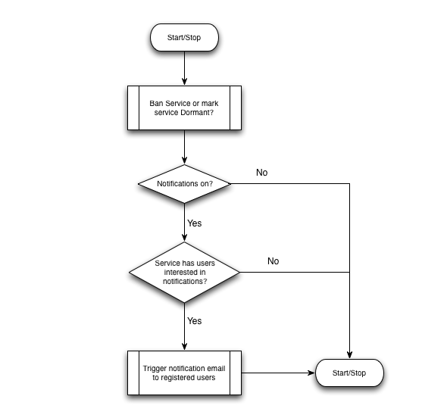
Figure 4 Notifications to registered users

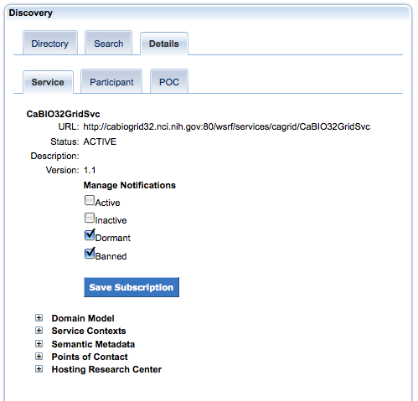
Figure 5 Manage Notifications screen

Advantages: This is a opt-in system and interested parties, which can be people other than the Point of Contact, can register their interest in receiving notifications
Disadvantage: Onus is on service developers and other users of the Portal to register for notifications. This might need user training and awareness. Some service developers are not pro-actively managing their services and thus it’s a bit of a catch 22.

